TRAINING ANNOUNCEMENT

Overcoming Size Differences

Tactics for Female Officers

L.O.C.K.U.P. Police Training Systems

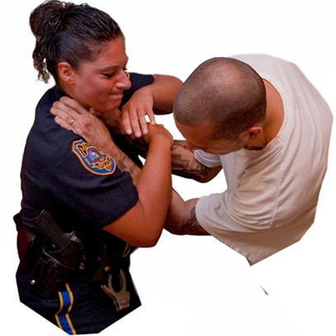24 Hours

REGISTER - Officers interested in attending must contact their agency training division for approval. A signed agency training authorization form or CJAO 15A registration form must be completed and emailed or faxed to the Academy by authorized training personnel prior to the start of class. Forms can be sent to [nancy.goyette@osceola](mailto:nancy.goyette@osceola)schools.net or faxed to 407-962-5265 or Dawn Gereau (407) 344-5080, ext. 15104  
dawn.gereau@osceolaschools.net

All materials will be provided by Criminal Justice Academy of Osceola. **This class is limited to 20 participants.**

**COURSE DESCRIPTION:** This three-day course is designed for female law enforcement officers to address violent encounters dealing with suspects of larger stature. When attempting to control larger suspects, size and strength differentials necessitate combat strategies less reliant on pure upper body strength. The concepts and techniques can be utilized by any officer addressing a larger suspect. The days are hands-on and physically and mentally challenging. Officers train and drill wearing vest, gun belt and long pants because anything else makes no sense.   
  
Topics include: Risk Assessment and Threat Indicators • Ground Fighting Counter Measures • Fear Management and Control , • Fighting Techniques and Fatigue • Understanding Weapon Integration • Decisive Takedown Manipulations • Active Diffusion Strategies • Team Approach and Strategies • Understanding Mass / Power and Kinetic Energy • Overcoming/Understanding Size Challenges • Using Your Size to Your Benefit • Proper Weapon and Target Selection, and Taser to Physical Control.

**The School District of Osceola County, Florida**

An Equal Opportunity Agency **Student Achievement – Our Number One Priority**

**Contact us at 407-518-5445 ● FAX 407-962-5265 ● *osceolaschools.net/otech***



**DATES/TIMES: April 11 – 13, 2022, 8-5 pm**

**LOCATION: Criminal Justice Academy of Osceola**

**Building 8, DT Room 121**

**501 Simpson Road ● Kissimmee, FL 34744**

**FEE:** Trust Funds will cover program costs.

**TRAINING:** Specialized Program eligible for

Mandatory Retraining.

**DRESS CODE:** Agency Authorized Training Attire – Full gear.

**INSTRUCTOR: Lt. Kevin Dillon (Ret.) and Dep. Amanda Stoupis**

**L.O.C.K.U.P. Police Training Systems**